MACH4METAL

Metalworking machinery
Transito 21,
6909 DA BABBERICH
Netherlands
Tel. +31 (0)316 – 247123
Fax. +31 (0)316 - 247956
info@mach4metal.com
www.mach4metal.com

Account No: 66.52.13.883
IBAN : NL33 INGB 0665 2138 83
BIC : INGBNL2A

CNC STUDER ECO 1000 External Grinding
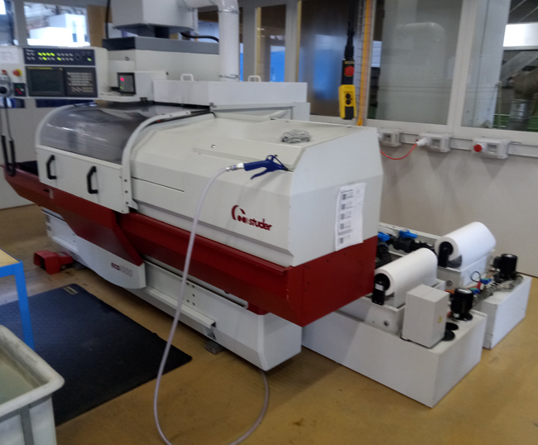
- Make : STUDER Swiss
- Type : eco 1000
- Serial : 022
- Age : 2003

- Centre height : 175
- Max. swing over bed Ø : 350
- Max. grinding length : 1.000

- Stone size : 500 x 80 x 127
- Table speed :
- Speed stone :
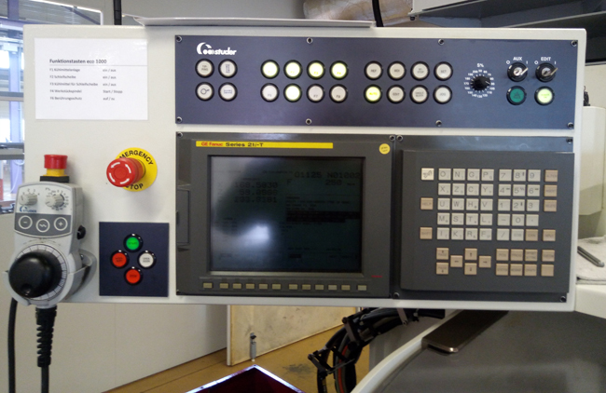

- Tailstock taper :
- Quill :

- CNC Control Fanuc 21i-T with remote
- Coolant system filtration system

- Movomatic length positioning
- Movomatic process gauging
- Movomatic diameter measuring head
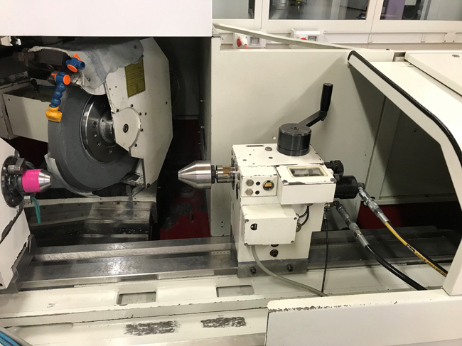
- Sensitron cut in detection

- Dimensions
- Length : 4.800
- Width : 2.300
- Height : 2.200
- Weight : 4.800
- Power :

Please Note: The above information has been obtained to the best of our ability and belief from, and from the manufacturers where possible. It is given in good faith, but its accuracy can not be guaranteed. Accordingly, it will not form a representation or constitute contractual terms. We advise you to check any vital details

